|  |
| --- |
| Adding Indicator Areas to Students in Sections |

1. Go to CYSH via your [Okta Homepage](https://cityyear.okta.com/app/UserHome) (cityyear.okta.com)
2. Find **Sections** on the blue ribbon and then click

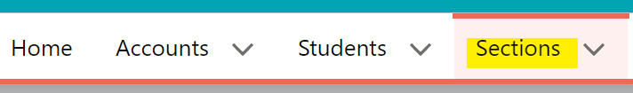

1. Select your preferred view and locate the section

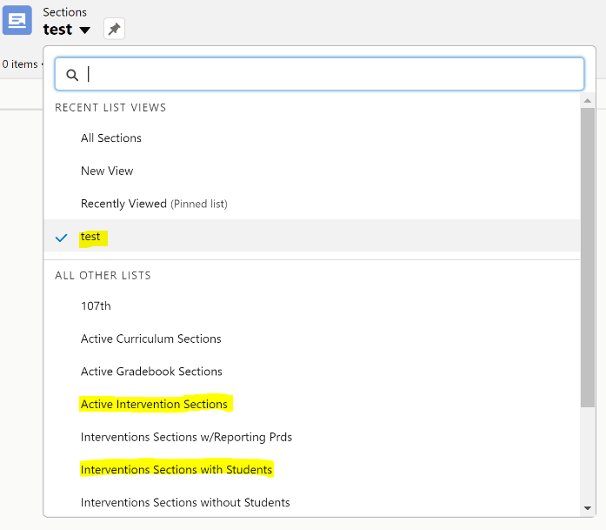

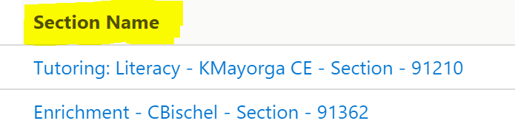

1. Click on Intervention Data on the top-right hand corner



1. Select all students using the checkbox on the top left

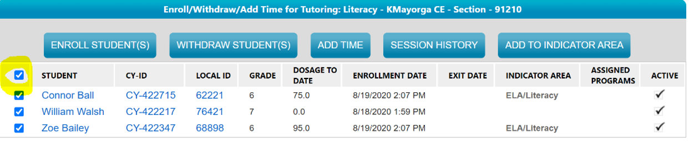

1. Click on the **Add To Indicator Area** button on the top

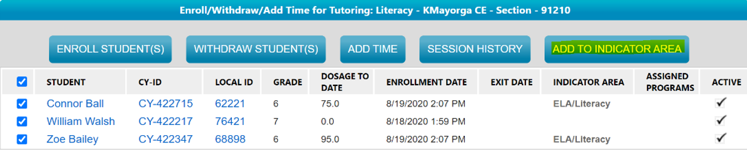

1. Select the Indicator date: The day the Student first became a focus list studnt

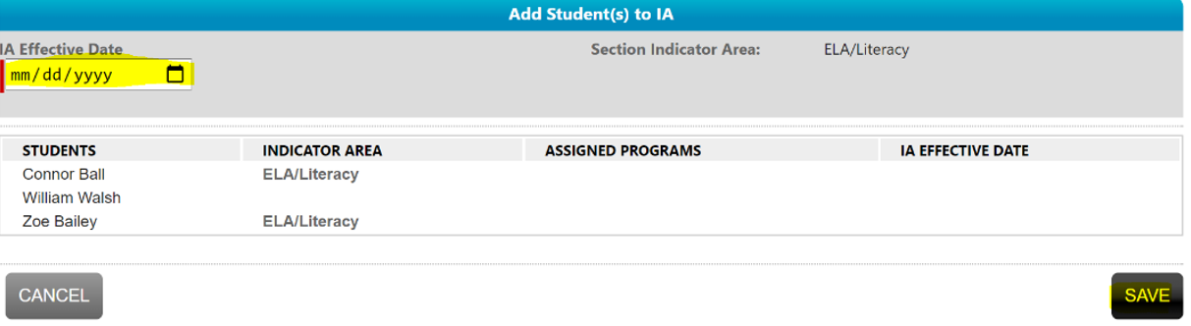

1. Click Save

